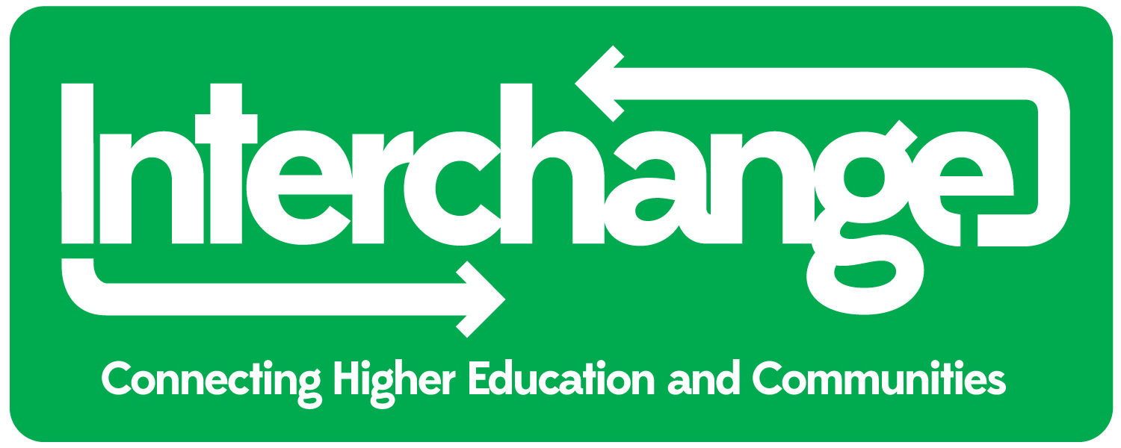
Are you a voluntary and/or community organisation (VCO)?

Do you require research or a work based learning project that will support the aims of your organisation?

Are you a registered charity?

If you have answered yes to any of the above then you SHOULD read on…

Interchange is a registered charity (charity number 1038129) and links Higher Education (HEIs) with local voluntary and community organisations (VCOs) from Greater Merseyside for the purpose of research and work-based learning projects. This is The Interchange Experience (TIE).

Our aim is to connect VCOs who have research or work-based learning project needs and students in Higher Education who are looking for research or work-based learning project opportunities.

Working collaboratively with VCOs and Students, we offer a wide range of projects to include:
- Evaluation reports and studies;
- Documentary and oral histories;
- Feasibility studies; community activities.

Interchange is based in one of its partner organisations, the University of Liverpool. Our students are from the University of Liverpool and are based in the School of Law and Social Justice.

We work with all VCOs or projects that are not-for-profit and/or have charitable aims.

Can a work based learning project or research project help your organisation?

Both a research project and work based learning project can provide you with evidence to assist with areas to include:
- Business Planning; Annual Reports;
- Funding applications; Improving services;
- Becoming more sustainable.

What can TIE Partnership do for your VCO in terms of providing access to free student research?

TIE’s philosophy is one of partnership between Higher Education and the voluntary and community sector. Neither will be exploited as the project is negotiated, collaborative, the end report will count towards the student’s degree and each partner should learn from the experience.

We make no charge for our service - but we do ask VCOs to meet the basic travel expenses incurred by the student(s) and to pay for the Disclosure and Barring Service (DBS) formally CRB check, if required.

If you have a project idea(s) and would like to discuss it further then please complete pages 2 and 3 below and e-mail it to

interchange@liv.ac.uk no later than

Friday 25th April 2014

We look forward to hearing from you

 interchange@liv.ac.uk
0151 794 2986
http://www.facebook.com/InterchangeLiverpool
http://www.liv.ac.uk/interchange/
https://twitter.com/Interchange_vco
Initial Contact: Booking Form
Name:
Job Title:
Name of Organisation:
Contact Tel: Contact Mobile:
Email: Website:

Tell us about your organisation

Are you a Charity? Y/N (if yes charity no:___) If no what is your status? ______

How many staff __ How many Volunteers__ How many Committee Members ___

Who are your main beneficiaries? (i.e. children and young people/BME/substance misuse)

How many years operational? ___ yrs Have you worked with Interchange before? Yes/No

Tell Interchange about the type of research or work based learning project you require:
The following questions are for guidance purposes only

- Background information on your VCO (no more than 200 words)

- A potential title for your project report:

- Tell us a little bit about why your VCO wants a research or work based learning project

- Tell us what you would want the student to do (i.e. produce guidelines / evaluation / a handbook / find out what systems are working effectively/develop a website / record oral histories) etc...

- Please list potential interviewees for the student (i.e. service users / your partner agencies / other projects / trustees / named individuals)

All applicants will be invited to discuss their idea(s) further

Please tell us (highlight in bold or underline) about the work your organisation does and the polices it has

1. Main activities of your work: (highlight all that apply)
- Welfare advice | - Arts
- Mentoring | - Community development
- Accommodation | - Education
- Health services | - Campaigning
- Counselling | - Research
- Information provision | - Grant-making
- Environmental | - Umbrella body
- Social care | - Other (please write below)

2. Main focus and groups you work with: (highlight all that apply)
- Children and families | - Volunteering
- Young people | - Domestic violence
- People with disabilities | - Mental health
- Lesbian, gay, bisexual, trans (LGBT) | - Substance misuse
- Women | - Homelessness
- Older people | - Unemployed
- Refugees and asylum seekers | - Carers
- Black and ethnic minorities (BME) | - Other (please write below)

3. Main areas you work in: (highlight all that apply)
- Liverpool | - Knowsley
- Sefton | - St. Helens
- Wirral | - Other (please state)

4. Policies: Please highlight any polices you have.

If you do not have some of these policies do you require Policy Development support? Yes / No

Please note: (this is not a comprehensive list. Only policies that may affect our students have been included)

A
Alcohol / drugs policy
Attendance at work during severe weather

B
Bullying

C
Code of Ethics
Compassionate/Domestic/Personal Leave

D
Data protection
Dignity at Work and Study
Disability Equality Policy / Action Plan
Disciplinary Procedure
Diversity and Equality of Opportunity Policy
Drugs / alcohol policy

E
Expenses reimbursement

F
Flexible Working

G
Gender Equality Scheme / Action Plan
Grievance Procedure

H
Harassment
Health & Safety
Holidays, hours of work, terms and conditions

I
Induction

M
Mentoring - How to Guide

P
Personal Details Form
Public Interest Disclosure (Whistleblowing) Policy

R
Race Equality Scheme / Action Plan

S
Safeguarding
Sickness Absence Procedure
Smoking Policy

W
Work Experience

